GENERAL GUIDELINES

FOR SUBMISSION OF PROJECT PROPOSALS FOR FINANCIAL ASSISTANCE

*Under*

**Electric Vehicle Solutions led by Startups for Component Manufacturing (EVolutionS) Program**

A New Funding Initiative

**CALL FOR PROPOSALS FOR TECHNOLOGY BUSINESS INCUBATORS**

**LAST DATE OF SUBMISSION: 20th April, 2025 by 11:59 PM IST**

**ONLINE MODE ONLY (**[**https://onlinedst.gov.in/Login.aspx**](https://onlinedst.gov.in/Login.aspx)**) NO HARDCOPY**

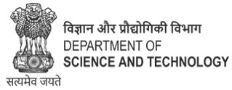

Climate, Energy, and Sustainable Technology (CEST), Division

Department of Science & Technology

Ministry of Science & Technology

Government of India

in collaboration with



1. **Call for Proposal**

Department of Science and Technology (DST), Government of India is pleased to launch an exclusive program, named as “Electric Vehicle Solutions led by Startups (EVolutionS)” to accelerate EV component manufacturing in the country. The program is uniquely designed with focussed value addition by way of engaging with Ministry of Heavy Industry (MHI), GoI and Automotive Component Manufacturing Association of India (ACMA) as supporting partners to aid the selected startups for pilot demonstration, testing, validation of components & to establish industry connects for speedy translation of EV solutions to market. The Program is aligned with the initiatives undertaken by Ministry of Heavy Industry (MHI) towards augmenting the localisation of components/sub-systems under Phased Manufacturing Program of PM E-Drive and also Production Linked Incentive Scheme of Advanced Chemistry Cell (ACC-PLI).

The program EVolutionS aim to strengthen manufacturing competitiveness by extending support to startups in product development, testing, validation and demonstration. The Program intends to accelerate the development of indigenous materials, components/ sub-systems of Electric Vehicle that includes Battery, Motors, Drives, Power Electronics and EV Charging Infrastructure. It is envisaged that the startups working in Electric Vehicle domain have opportunity to translate their prototypes (proof of concepts) into commercially viable products by establishing robust supply chain within the country thereby promoting ATMANIRBHAR BHARAT (self-reliant India) and aligning with the goals of Viksit Bharat.

1. **Background**

India’s clean energy transition is moving at rapid pace with several initiatives by the Government (a) to meet 50% of India’s energy requirements from renewable energy by 2030; (b) to reduce projected carbon emissions by 1 billion tonnes by 2030; (c) to achieve Net Zero by 2070. The Government also aims to achieve the target of 30% road transport vehicles to be electric by 2030. In these directions, Government has initiated several schemes/programs to support Indian industry thereby creating a conducive ecosystem to accelerate Zero Emission Vehicle (ZEV) penetration in the country.

In order to promote R&D in e-mobility, **Department of Science and Technology (DST)** brought out a **White Paper on Catalysing Technology Led-Ecosystem for e-Mobility**, which highlighted hindrances in eMobility and potential solutions to address these challenges thereby creating a technology led ecosystem. DST also brought out three thematic R&D Roadmaps on EV Tropical Battery, Power Electronics and Machine Drives, and EV Charging Infrastructure (https://dst.gov.in/news/research-and-development-roadmap-electric-mobility). The recommendations of these reports have been translated in creation of MAHA Electric Vehicle Mission (EV-Mission) which was recently launched under Anusandhan National Research Foundation (ANRF), DST, GoI.

Towards accelerating faster adoption of electric vehicles in the country, **Ministry of Heavy Industry (MHI)** has been playing a pivotal role by supporting electric vehicle/ automobile industry through various national level schemes/ programs. These includes: Faster Adoption and Manufacturing of (Hybrid &) Electric Vehicles (FAME I & FAME II), Production Linked Incentive Scheme of Advanced Chemistry Cell (ACC-PLI) and recently announced PM Electric Drive Revolution in Innovative Vehicle Enhancement (PM E-Drive) schemes. FAME I & II provided crucial initial throttle to EV penetration in the country to various financial incentives to consumers and OEMs. While ACC PLI Scheme aims to boost India's manufacturing capacities in the energy storage sector via financial incentives, the PM E-DRIVE Scheme focused to accelerate EV adoption and establish essential charging infrastructure across the country, promoting cleaner and more sustainable transportation.

**The Automotive Component Manufacturers Association of India (ACMA)** plays a vital role in the growth and development of the auto component industry in India. With its wider network of industries, ACMA promotes trade, technology up-gradation, quality enhancement, and the collection and dissemination of information. ACMA extends support in formulating policies and regulations pertaining to the Indian automotive component industry helped manufacturing competitiveness in auto component industry.

1. **Significance of the EVolutionS Program**

At present, the industry depends heavily on imported materials, components/ systems due to lack of domestic raw material supply chain and manufacturing base in the country. In order to address these challenges many innovative start-ups have also ventured into this domain. While manufacturing industry is gearing up to ramp up their manufacturing capacities to meet domestic demand, there is a need to give a push to start ups to come up with commercially viable products to support the industry.

The program will be a key catalyst and enable to identify, incubate and support startups in developing innovative products (materials, EV Components/ sub-systems and EV Chargers) on fast-track mode as envisaged under Phased Manufacturing Program (PMP) guidelines of PM e-Drive Scheme. This program is also well aligned with MHI’s Advanced Cell Chemistry (ACC)-PLI Scheme targeting towards localisation of components in the battery. The program aims to encourage deeptech startups in creating robust indigenous supply chain of materials, components/ sub-systems and encourage domestic manufacturing capabilities to address the identified needs of the industry.

The program also helps in standardisation of EV components. Standardization enables different systems and technologies to work together smoothly. It helps the industry to develop components at a lower cost and produce higher volumes of standardized products, thus enabling the component manufacturers to achieve economy of scale. It also helps to avoid proliferation of sub-standard components that may be associated with safety risks. The need for standardization of electric vehicle components and subsystems has been emphasized in the R&D Roadmaps of DST as well as the EV Task Force on Power Electronics, Devices and Motors set up by the Ministry of Heavy Industry (MHI).

1. **Scope of the EVolutionS Program**

The program aims to accelerates the transition of EV technologies from Proof of Concept/Prototype (TRL 3-4) to commercially viable products (TRL 6-8) by demonstrating prototypes in real-world settings, thereby reducing reliance on imports and strengthening the domestic EV supply chain. The focus is to bridge the gaps by strengthening the EV supply chain & the missing links of Research & Development (R&D), challenges in manufacturing, testing & validation, standardisation of EV components, market entry & commercialization enabling the speedy localization of EV components.

Hence, proposals are invited from startups, who have demonstrated indigenous capability in developing materials, components/ sub-systems inhouse within the country (reaching TRL 3-4) and meeting specific standards/guidelines issued by Government of India. The Program will provide opportunity to upscale these technologies towards its commercialisation. The focus is to bridge the gap in terms of Research, Development & Deployment (RD&D) manufacturing challenges, functional prototype development & scaling up, pilots, testing & validation, market entry & commercialization. At the end of this, it is expected that the startup will be able to fully localise the manufacturing (i.e. sourcing of materials, stamping, plating, moulding, assembly etc) and also bring down the total cost of manufacturing of these components/ sub-systems.

The call covers development of components for Electric 2, 3 & 4-wheelers (including L5, E-rickshaw and E-cart), e-buses and EV public charging infrastructure. The emphasis of the present call is to accelerate localization of core EV components which are at Technology Readiness Levels (3-4) for their commercialisation at fast-track mode i.e. within 36 months. The final deliverables for all these projects should demonstrate industrial grade materials, components/ sub-systems (TRL 6-8) or beyond for adoption by manufacturing industries.

It is expected that this Program can significantly bolster startups and Make-in- India in this space thereby strengthening the capacity and capability of Indian Industry for long term sustainability and end-to-end value creation across the value chain. This initiative aims to drive the development of indigenous products and technologies at fast pace. The Program aligns with the vision of **ATMANIRBHAR BHARAT** (self-reliant India) and contributes to the goals of **Viksit Bharat**. The program is focused on the rapid integration of advanced technologies into EVs, prioritizing localization.

**Key Components/ Sub-systems identified**

There are two types of challenges faced by startups in localization of EV components:

1. Manufacturing Challenges: Many startups have developed Proof of Concepts/Prototypes of EV Components but their scale up is hindered due to manufacturing challenges.
2. Standardisation of Components: There is need to standardize EV components to meet tropical environmental conditions and also make them robust and foolproof to both domestic and also for export market. Hence, validation of these components in real conditions is crucial.

The EVolutionS program will focus towards translation of innovative technologies that have reached up to proof of concept / prototype level (i.e. TRL 3-4), to commercially viable products (TRL 6-8) meeting the requirements of industry so as to reduce import and boost domestic supply chain within the country. The focus is to bridge the gap in terms of Research, Development & Deployment (RD&D) manufacturing challenges, functional prototype development & scaling up, pilots, testing & validation, market entry & commercialization. At the end of this, it is expected that the startup will be able to fully localise the manufacturing (i.e. sourcing of materials, stamping, plating, moulding, assembly etc) and also bring down the total cost of manufacturing of these components/ sub-systems. The program will also aim at validation of some of the standards identified for critical components/ subsystems to offer economy of scale, higher level of safety, performance and user convenience.

**TROPICAL EV BATTERY COMPONENTS/ SYSTEMS**

1. **Novel Battery Materials for Next-generation Advanced Chemistry Cells (ACC):**
   * 1. Pilot scale demonstration of Cathode & Anode active materials, separators, binders, and Electrolytes (liquid & solid-state) for the Next-generation ACCs.
     2. Pilot scale demonstration of emerging alternative chemistry cells
     3. Innovative solutions for ACC manufacturing processes
2. **Innovative Solutions for Battery Circularity**
   1. Innovative solutions for commercial recycling technologies to improve efficiency, increase battery life, cost-effectiveness & environmental sustainability
   2. Pilot scale demonstration of emerging recycling technologies like direct recycling, etc
   3. Pilot scale demonstration of innovative black mass processing solutions
   4. Pilot scale demonstration of innovative solutions for reuse application of retired EV batteries
   5. Pilot scale demonstration of AI/ML-based Cell & Battery Diagnostic models for estimation of Residual Useful life.
   6. Pilot scale demonstration of innovative solution for Battery Passport/ Aadhar System
   7. Innovative strategies to increase battery life.

**POWER ELECTRONICS, MACHINE DRIVE COMPONENTS**

1. *Charging Systems:* On Board Charger (WBG based) / External Portable Charger
2. Permanent Magnet Manufacturing for Traction Motors for EVs.
3. Electric Drive Unit: 3 in 1 Motor + MCU + Gearbox Development
4. *Control Units:* Vehicle Control Unit (VCU), Traction Motor Control Unit (MCU), Battery Monitoring Unit (BMU)
5. Power Distribution Unit
6. *Traction Inverters:* Silicon based inverters; WBG based inverters
7. *Power Converters*: Rectifiers/AC-DC Converters, DC-DC Converter (Silicon based and WBG based)
8. *Power Modules* for traction inverter, on-board charger, auxiliary inverter, (Silicon and WBG based) etc.
9. Thermal Management System for Motors and Power Electronics.
10. *Digital Twins*: Digital Twin for battery manufacturing, EV components/ subsystems. Pure software development without any experimentation/ test/ validation will not be supported

**CHARGING INFRASTRUCTURE**

1. Inductive/wireless Charging systems (static and dynamic)
2. Renewable (microgrid) based green charging technologies for Parkbay charging
3. Charger Controllers: Electronic Controllers for communication with EV, Charge Control, backend communication and other functions
4. Pantograph and Megawatt hour charging technologies for EVs.
5. Integrated thermal management system for charger and battery systems
6. Battery Swapping technology & systems

**STANDARDISATION OF EV COMPONENTS**

1. **Charging Infrastructure and Grid Integration** 
   * + Pantograph based charging system
     + Wireless Charging Systems, communication standards
     + Megawatt Charging System
     + Microgrid, distributed energy resource management systems integrated with DC charging
     + Vehicle grid integration; Vehicle to Grid (V2G) systems
     + Cybersecurity for EV subsystems and charging systems
2. **Vehicle Systems and Components** 
   * + Battery Standardisation for manufacturing and recyclability, secondary uses; safety issues such as thermal runaway, immersion, vibration etc;
     + Power Electronics Components
     + Electronic Control Hardware
     + Vehicle Control Unit (VCU)
     + Light EV DC charging system
3. **Expected Outcome**

* The program will support start up industry to develop components aligned with Phased Manufacturing Program (PMP) under PM E-Drive Scheme and Advanced Chemistry Cell (ACC) PLI Scheme of MHI.
* The Program will accelerate translating prototype/PoC (TRL 3-4) into commercially viable products, reaching higher TRL (6-8) within short span of time thereby addressing domestic needs of EV industry. It is expected that startups will be able to localise the manufacturing and also bring down the total cost of manufacturing of these components/ sub-systems
* This program will enable startups to generate IP, and further commercialization of the product in the form of licencing etc.
* Through standardisation of critical EV components, the program will accelerate in large scale implementation of EVs in the country. The PoC and validation activity will be undertaken to verify the concepts of standardisation, which will help indigenous manufacturing of the components for scaling up.
* The program will be evaluated by an appointed committee (Program Advisory Committee) who will mentor these startups to successfully graduate at every phase and launch their products and receive expression of interest from manufacturers / industry thereby creating market for their products.

1. **Program Structure**

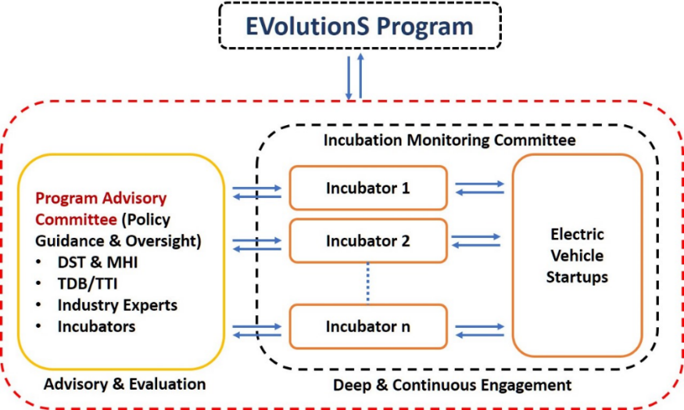

**The Startup will be selected by Program Advisory Committee set up by Department of Science and Technology (DST), GoI, which will steer the Program by review, selection of startups and monitoring of overall program. EVolutionS Program TBI Partners (EPIP) will pitch to the selected Startups and Startups will pick any of the TBI from EPIP for receipt of the grant, incubation through EPIP as per the norms of the DST.**

**7**. **Program Advisory Committee (PAC):**

A Program Advisory Committee (PAC) will be constituted by DST, which will be responsible for the overall execution and monitoring of the EVolutionS Program. The PAC will evaluate and select TBIs for allotment of EVolutionS grants, monitor progress, and take all necessary measures for efficient utilization of funds towards fulfilment of objectives of EVolutionS program.

The Program Advisory Committee (PAC) will comprise of the following members:

1. Chairman, an individual of eminence
2. Financial Advisor, DST or his representative
3. Representative of Department of Science & Technology (DST)
4. Representative of Ministry of Heavy Industries (MHI)
5. Representative of ACMA
6. At least three expert members nominated by Secretary, DST from the startup ecosystem, investors, experts in the domain of R&D, technology development and commercialization, entrepreneurship and other relevant domains.

**8. Eligibility criteria for the EVolutionS Grant**

**8.1 Eligible Criteria for Start-ups/** **incubatees:**

The eligibility criteria for a startup to apply for the EVolutionS Grant are as follows:

1. A startup, should be registered by DPIIT at the time of application. If not registered, funds will only be released after successful registration by DPIIT.
2. Shareholding by Indian promoters in the startup should be at least 51% at the time of application to TBI for the scheme, as per Companies Act,2013 and SEBI (ICDR) Regulations, 2018
3. Only for ‘Indian Companies’ defined as ‘holding company registered in India’, and ‘IP resides in India’, and ‘majority owned in India’.
4. Shareholding by Indian promoters in the startup should be at least 51%, as per Companies Act, 2013 and SEBI (ICDR) Regulations, 2018.
5. Startup must have reached to the level of proof of concept/ technology validated in lab (TRL 3-4) to develop a product or a component with market fit, viable commercialization, and scope of scaling. The project leading to development of a device/prototype with TRL 6 and above, and having potential for commercialization will be preferred for financial support. Basic R&D proposal leading to only research publications may not be considered under this call. Besides for TRL level requirement, Project Leader (PIs) are advised to look into Technology Readiness Level (TRL) for implementation of the technology at Annexure II.
6. Startup with proposed objectives and deliverables should not have received funding support in grant mode not more than Rs. 20 lakhs in last 5 years from any other Government funding programs for startups.
7. EVolutionS support can be provided only once to any startup.
8. The startup should be using technology in its core product to solve the problem being targeted.
9. The Project leader (PI) can submit only one proposal against this call. Submission of more than one proposal from a PI would be liable to be disqualification of all the submitted proposal.
10. Project Leader:
    1. Every proposal must clearly identify a Project Leader who will take responsibility for the technical and managerial aspects of the project execution.
    2. The Project Leader must be technically qualified to undertake the project. The Project Leader must have completed basic undergraduate training in any discipline.
    3. In the event that the proposal is shortlisted for presentation in front of Selection Committee(s), the Project Leader will be required to present the case for support. In the event that proposal is shortlisted for funding support, the Project Leader will be required to sign the project agreement.
    4. Project Leader must be a shareholder in the applicant company.
11. As per the recommendation of the Program Advisory Committee (PAC), Grant can be terminated by DST at any stage if the Grant has not been properly utilized or appropriate progress has not been made. Unspent balance with the startup should be refunded to DST through TBI.
12. Any dispute on any matter related to the implementation of the project, the decision of Competent Authority, DST, shall be final and binding on the Implementing Agency.
13. DST reserves the right to modify these terms and conditions governing the grant-in-aid from time to time.

**8.2. What is not supported**

1. Basic research Projects below TRL 3
2. Exploratory research/project studies
3. Project having low element of novelty
4. Project with the same objectives which has already been supported by other Govt Ministries.

Note: EVolution grant is not a research fellowship and can’t be used to support PhD or any other academic research.

**8.3. Eligibility Criteria for Technology Business Incubators**

The eligibility criteria for an TBI to apply in the EVolutionS Program are as follows:

* + - 1. Technology Business Incubator (TBI) must be a legal entity:

A society registered under the Societies Registration Act 1860, or

A Trust registered under the Indian Trusts Act 1882, or

Not-for-profit Private Limited company registered as Section 25 company under the Companies Act 1956 or Section 8 company under the Companies Act 2013

* + - 1. TBI must have facilities to incubate at least 20 startups at a given point of time.
      2. In case of sector agnostic TBI, it must have necessary facilities, state of the infrastructure, competent team and a robust service support network to incubate startups.
         1. Must have incubated more than 100 startups since inception &
         2. At least 10 start-ups must be in cleantech domain including EVs.
      3. In case of a sector focused TBI in cleantech/clean energy, it must have incubated minimum of 50 start-ups since inception including EVs.

*Additional Points:*

* + - 1. TBI must have a full-time Chief Executive Officer, supported by a competent team responsible for mentoring startups in testing and validating ideas, as well as fund raising, and external investment.
      2. TBI should assess provide handholding and essence to enhance & enable startups to navigate through different phases: Ideation, technology ready, industry ready, infrastructure ready etc.
      3. TBI must have been assisted by Central Government.
      4. In case the TBI has not been assisted by Central Government:

TBI must be operational for at least three years

Must have at least 10 separate startups undergoing incubation in the TBI/centres physically on the date of application

Must present audited annual reports for the last 2 years

* + - 1. Program Advisory Committee (PAC) is empowered to relax the above criteria for deserving TBI as deemed to.
      2. Program Advisory Committee (PAC) is also empowered to set any additional criteria as may be fit for the benefit of the Program.

**9. Role of EVolutionS TBIs**

The EVolutionS program is implemented through TBIs located across the country. DST shall sign MoU with these TBIs for implementation of the scheme. A Call for Proposals mentions the names of TBIs for the particular call.

Responsibilities of EVolutionS TBI include:

* + Create awareness about EVolutionS scheme through outreach programmes, social media etc.
  + Provide mentoring for proposal submission to EVolutionS aspirants
  + Receive online applications
  + Screen EVolutionS applications for eligibility and suitability for the scheme
  + Conduct first level screening through online review of eligible applications and recommend shortlisted proposals for approval to DST
  + Conduct TEP meeting for shortlisted applicants and submit detailed recommendations to DST for further approval
  + Handhold and provide pitching guidance to applicants for presentations before TEP and PAC
  + Conduct technical & financial due diligence of the applicants shortlisted by the PAC and submit due diligence reports to DST for final approval
  + Sign agreement with finally selected innovators
  + Verify requirements for release of funds
  + Release funds (milestone based) to separate no-lien account
  + Monitor the milestones and provide continuous mentorship/handholding for activities related to IP management, legal, contracts, mobilizing resources, fund raising and other business development related activities
  + Organize workshops/ seminars/ mentoring sessions for EVolutionS grantees (startups)
  + Provide a platform for interaction with Experts, Mentors and other academic/ TBIs.

**10. Selection of TBIs**

Online Applications will be invited from TBIs across India to participate in the program on https://www.dst.gov.in or any other platform specifically designated for the purpose.

10.1 TBIs shall be selected on the basis of the following parameters:

a. Fulfilment of eligibility criteria

b. Competency of the Core Operational Team, contact details of CEO and person handling managerial position and also funding related matters with complete details

c. In case of sector agnostic TBI, it must have necessary facilities, state of the infrastructure, competent team and a robust service support network to incubate startups. (i) Must have incubated more than 100 startups since inception & (ii) at least 10 start-ups must be in cleantech domain including EVs.

In case of a sector focused TBI in cleantech/clean energy, it must have incubated minimum of 50 start-ups since inception including EVs.

List of startups supported and role of TBI, list of top 10 mentors including clean tech and EVs, should be mentioned for evaluation by the Committee. The Program Advisory Committee appointed by DST can relax the norms for highly deserving TBIs working in clean tech domain including EVs.

d. Funding support extended to incubatees in last five years:

* Investment agreements signed between TBI and startups and also indicate the number of agreements in clean tech including EVs
* No. of startups invested in specific to clean tech domain including EVs.
* Total investments raised by incubatees from external sources in clean tech domain including EVs.

e. Mentoring provided to incubatees in last 5 years in clean tech domain including Electric Vehicles (EVs).

f. Other support extended to incubatees in last three years:

* Industry/Corporate connects to market specific to clean tech domain including EVs.
* Events held for stakeholder engagements specific to clean tech domain including EVs.
* Intension for collaboration to facilitate deeptech startups for product development. Please provide overall details and in specific to clean tech domain including EVs.

10. 2 Program Advisory Committee (PAC) meetings will convene at least quarterly to:

1. Evaluate the applications received during the period
2. Select TBIs for funds under the Scheme
3. Decide the total amount of fund and number of instalments in which it is to be allocated to each TBI
4. Specify milestones to be achieved by each TBI for release of instalments

10.3 PAC shall also monitor progress of TBIs against sanctioned funds under the program and take further actions as may be required

10.4 PAC may lay down improved guidelines for selection of TBIs under the program from time to time

**11. Roles of Participating and Relevant Ministries**

1. EVolutionS TBIs and DST will provide continuous mentoring support to the grantees, including but not limited to: product development, testing, validation, market entry and commercialisation Technical Mentoring (Connect with Technical Experts); IP Support; Legal Support Networking and Outreach; Trainings; Regulatory Advice; Business Mentoring; Connect with Investors and Any other assistance on case basis
2. MHI will be the supporting partner which has got strong base in implementation of various Schemes/ Programs to support EV sector. The specialised manufacturing & testing facilities of MHI (such as ARAI, iCAT, CMTI, NATRAX, etc.) may be leveraged for enabling startups to translate their prototypes speedily into commercially viable products aligned with Phased Manufacturing Program of PM e-Drive.
3. Automotive Component Manufacturers Association (ACMA) will facilitate the selected startups under EVolutionS Program to access the facilities of industries to demonstrate/validate their components/technologies before final testing and certification by test agencies.

**12. Project Duration**

The funding is provided for a period of up to 36 months.

**13. Financial Support for Startups under EVolutionS Program**

1. This Program spanning 36 months will be fully funded by DST with funding support of Rs.50 lakhs (as Rs. 20 lakhs as grant-in-aid & remaining Rs. 30 lakhs with 2-3% equity/equity linked instruments i.e. Compulsory Convertible Debentures) to about 50 Startups through DST’s strong network of TBIs, towards R&D, product development, testing, validation, market-entry & commercialization.
2. DST supported TBI after onboarding will be provided with 5% of the total start-up funding for EVolutionS, which is aligned with NIDHI Seed Support Program as the overhead charge for the selection process, monitoring and management of the start-ups. TBI will be responsible to manage the start-up funding (grant & equity/equity linked instruments i.e. Compulsory Convertible Debentures) and monitoring of the progress. Additionally, TBIs may be granted Rs.10 lakhs/year towards capacity building, organising thematic workshops/ seminars, networking with stakeholders, preparation of knowledge series documents, forging international collaborations etc. as directed by program division of DST.
3. The project is implemented in a milestone-based manner and the fund should be released on successful completion of milestones as decided by the Program Advisory Committee (PAC) constituted by DST. Last instalment is released after submission of project completion report. This is typically in the nature of reimbursement.
4. All the funds to be disbursed through TSA hybrid mode.

**14. Guidelines for Disbursement of EVolutionS Fund to Startups by TBIs**

14.1 EVolutionS Fund to an eligible startup by the TBI shall be disbursed as follows:

* + 1. Up to Rs. 20 Lakhs as grant-in-aid & remaining Rs. 30 lakhs (in equity/ equity linked instruments i.e. Compulsory Convertible Debentures) for translating Proof of Concept/ prototype development to commercially viable product. The grant shall be disbursed in milestone-based instalments. These milestones can be related to development of prototype, product testing, validation, building a product ready for market launch, etc.
    2. EVolutionS fund shall strictly be utilized for the purpose it has been granted for.
  1. The TBI shall execute a legal agreement with the selected startups before the release of the first instalment. The TBIs shall ensure that the necessary terms and conditions, including milestones related to the Seed Fund are clearly detailed in the agreement.
  2. Subsequent disbursement would be linked to the achievement of previously specified milestones as per agreement between the startup and TBI
  3. For grants, the first instalment to any selected startup shall be released not more than 60 days from the date of selection. The startup shall submit the interim progress update and utilisation certificate to initiate the release of subsequent installment of grant.
  4. Startup shall submit final report and audited utilisation certificate at the end of the project duration. For failed ventures, the entrepreneur will share his/her learnings and the reasons for failure in the report and submit this along with the utilisation certificate for the fund amount.
  5. The TBI or any of its staff members shall not charge any fee in cash or in kind from applicants or beneficiaries under the scheme for any process of selection, disbursement, incubation, or monitoring.

**15. Accounting and Utilization of funds**

15.1. The TBI shall maintain an exclusive TSA account. Funds under this scheme shall be released into that account in milestone-based three (or) more installments.

15.2 Any net return received from beneficiary startup can be used for further funding in startups as per guidelines of this scheme (net returns shall include principal, interest, and profits). In case of no further funding of startups using this money for three years, this shall be returned to DST.

15.3 Each TBI shall report the funds sanctioned, received, and disbursed to each startup for each financial year

15.4 TBIs would also submit detailed report on status of utilization of funds and audited expenditure for each financial year.

**16. Application process**

* 1. The Call for Proposals is advertised through one or more means that may include DST website, newspapers, journals and magazines.
  2. The Call for Proposals is typically open for a period of up to 45 days.
  3. The EVolutionS Scheme is implemented across the country through DST EVolutionS TBIs. Names of the EVolutionS TBIs and their responsibilities will be mentioned are at ………….
  4. Application for EVolutionS needs to be submitted online ONLY through DST website or EVolutionS TBIs website.
  5. Applicants are advised to fill-up and submit their applications early without waiting for the last date in order to avoid last minute rush. Please note that the online system will stop accepting applications automatically at the specific date and time mentioned in the Call details.
  6. Applicants are advised to provide sufficient details in their applications to allow for an informed and fair evaluation/review.

1. Documentary Evidence:

Applicants are expected to show documentary evidence for verification by EVolutionS TBIs:

* 1. **Before Technical Expert Panel (TEP)** 
     + Letter of commitment from Scientific Advisors/ Mentors to serve as honorary advisors
     + Letter of intent of key members of the technical team
     + Letter of interest/intent from the TBI
     + Evidence of access to unique facility(ies) needed to execute a project
     + Evidence of access to key samples needed to execute the project
  2. **Post Expert Selection Panel (ESC)**:
     + Letter of acceptance or MoU with TBI
     + Formal agreements/ MoUs with other key facility(ies) providers/ suppliers
     + Any other due diligence documents requested on case-to-case basis by EVolutionS TBIs (e.g. technology inlicensing; IP rights clarification; NoC from Institute etc.)
     + Undertaking by the applicant that the project with same objectives and deliverables has not received funding from any other agency.
  3. Requests for changes in a proposal once submitted will not be entertained.
  4. Providing incorrect information intentionally is viewed adversely and may lead to disqualification.

**17. Selection process**

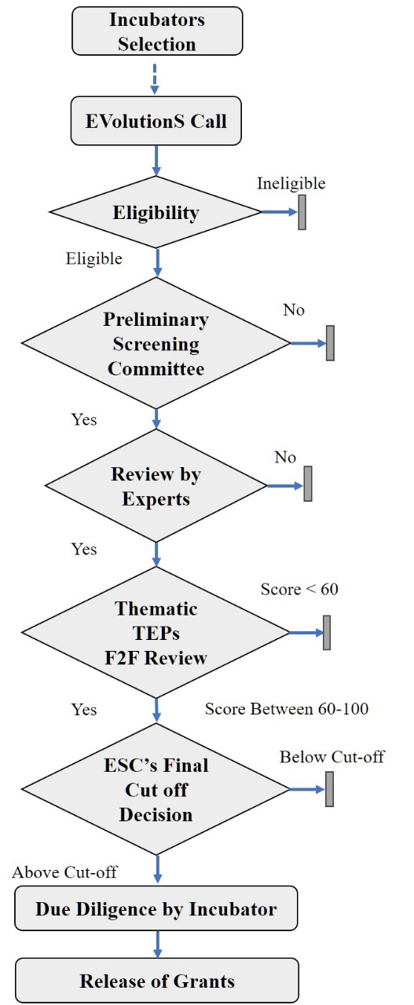

EVolutionS selection is a multi-tier process involving following steps:

• **Step 1:** Eligibility Check: EVolutionS TBIs screen the applications for eligibility requirements as laid out in the scheme document and appropriateness under EVolutionS program.

• **Step 2:** Examination by Preliminary Selection Committee (PSC): The PSC examines all eligible proposals on following contours: Scheme fit, availability of adequate technical details which are minimally required for online review; Plagiarism

• **Step 3:** Review by subject matter experts: Proposals recommended by PSC are reviewed online by 3 or more subject matter experts.

• **Step 4:** Presentation before Technical Expert Panel (TEP): Based on expert reviews, shortlisted applications are called for a Face-to-Face presentation before Technical Expert Panel (TEP). The TEPs are conducted in a thematic manner where all proposals of a particular theme are evaluated together by a common committee. All proposals are scored by individual TEP Experts and Geometric Mean of Individual Scores is used to arrive at the final score for a particular proposal.

o Proposals with score ≥60 are considered at the next step (PAC)

o Proposals with score <60 are not considered further

Step 1 to Step 4 will be coordinated by respective TBIs and TBI will send the shortlisted proposals for further evaluation by Program Advisory Committee (PAC) constituted by DST.

**• Step 5:** Scoring Cut off decision by the **Program Advisory Committee (PAC)**(recommended by DST):PAC takes the final decision with regard to the cut off score for final selection. Proposals above the decided cut off will be considered for further due diligence. PAC may choose to have either the same or differential scoring cut off across the themes.

**• Step 6:**PAC recommended applications are then subjected to final financial and technical due diligence by the TBI. This may require a visit by TBI representative(s) to the applicant’s site and involves following steps:

* Reconfirming eligibility by verification of original documents
* Legal, technical and financial due diligence
* Confirming applicant’s claimed resources: Space, equipment, manpower, advisors, incubation services, samples etc
* Confirming compliance strategy with regards to safety, ethics, waste disposal etc.
* Confirming for any special guidance by PAC
* Justification of budget (usually by verifying quotations); meeting budget caps and other requirements
* Finalization of milestones, budget and payment schedule; defining clear measurable milestones.

**18. Indicative evaluation criteria**

EVolutionS Proposals are based on the following parameters during review and Technical Expert Panel Stage which includes: Value Proposition/Differentiation, Technical Viability, Novelty, Commercialisation Strategy, Strategy to overcome challenges, EVolutionS project plan, Team Strength/Passion, Business Perspective, Potential (Clarity/Team’s view, Commercialization Potential) as decided by Program Advisory Committee (PAC).

**19. Signing of Agreement, Fund Disbursement, Monitoring and Review process**

* + For the proposals finally approved for funding support, TBIs sign agreements with grantees (startup) on behalf of DST.
  + Necessary guidance notes and templates are provided to startup/grantees by respective TBIs.
  + All grantees are required to open a separate, auditable, no-lien bank account with a scheduled bank in order to receive the funds.
  + Based on approved project milestones, respective TBIs periodically monitor progress and review the project. Grantees have to submit periodic reports and utilization certificates in the prescribed format to the TBI.
  + The project progress is also monitored by committee appointed by DST regularly including a face-to-face presentation towards completion of the project.
  + It is mandatory for all grantees to interact with at least 2 investors during 36 months of EVolutionS project and include the feedback in the final report.

**20. PROCEDURE FOR SUBMISSION OF PROJECT PROPOSALS**

The Project Proposal could be submitted as per the following instructions:

1. **Step 1** - Applicant is requested to submit online application form (through E-PMS Portal of DST at <https://onlinedst.gov.in/Login.aspx>) and download the same.
2. **Step 2**- Further, the applicant is requested to fill the application form (.docx) provided below along with the Program Guidelines and convert into .pdf document.
3. **Step 3**- **A soft copy in pdf format (by merging filled-in online application from E-PMS portal of DST and also filled-in application format provided along with guidelines, with all enclosures/documents) to be emailed to sureshbabu.muttana@gov.in on or before 20th April, 2025 (11:59 pm).**
4. NO HARDCOPY of the project proposal should be submitted.
5. Application received without the above documents with incomplete information will not be entertained.

Contacts: Any inquiries to this Call should be directed to: (Include subject: EVOLUTIONS TECHNOLOGY BUSINESS INCUBATOR CALL DST)



**Application Format for inviting Proposals from EVolutionS Program Incubation Partners (EPIP)**

Closing Date: 20th April, 2025 by 11:59 PM IST.

**ONLINE MODE ONLY (**[**https://onlinedst.gov.in/Login.aspx**](https://onlinedst.gov.in/Login.aspx)**) NO HARDCOPY**

**A. GENERAL INFORMATION**

1. Name of the applicant TBI
2. Full address of the applicant TBI
3. Name of the Institution where TBI is hosted
4. Year of Establishment of the applicant TBI
5. Legal Status of the TBI (Not-for-profit/Regular Society/Section 8 companies Act)
6. Website of the applicant TBI
7. Is the applicant TBI a TBI supported under DST-TBI/NIDHI- TBI etc. (Y/N), If Yes please mention the date of sanction and total fund sanctioned & disbursed till 2024-25.
8. Is the applicant TBI has received financial Support by any other government department/state govt/entity (DBT-BIRAC, DPIIT-SISFS, NITI Aayog’s AIM, MeitY, Ministry of Defense - iDEX, etc. Kindly specify the details), sanctioned & disbursed till 2024-25.
9. Attach the TBI Registration documents (Attach a separate Annexure - 3)
   * Certificate of the Registration
   * MoA and AoA
   * Audited Balance sheet of the last 2 years (FY 2022-23, 2023-24)

10. NGO Darpan Id

**B. GOVERNANCE AND TEAM OF THE APPLICANT TBI**

1. Name Head/CEO of the TBI & his/her designation of Head/CEO of the TBI and date of joining
2. Contact Details of Head/CEO of the TBI (Mobile no. and Email address)
3. List of Governing Body Members/Board of Directors (Attach a separate Annexure - 2)
4. Is there a dedicated core team member conversant with Financing & Funding of Startups (Y/N). If Y, please attach the details of his/her education, qualification and experience. Also, include the list of full-time officers/executives at managerial level at the TBI (provide details in C5 below) not more than 500 words

**C. PROFILE OF THE TBI**

1. Brief overview of the applicant TBI. (Max 200 words and description must include the following)

* About the TBI
* Total number of startups supported (since inception and in last 3 years) Total numbers of startups in Clean-Tech & EV domain at TBIs, please specify the details.
* Impact created on the ecosystem (not more than 100 words)
* Provide the web-link for the list of startups supported to date with details (incorporate in A6)
* Entry and exit policy, value added services TBI provided for cleantech startups

1. Core competences of the TBI
2. Thrust areas of the TBI
3. Physical Infrastructure (Size of the TBI in sq.ft) &

highlighting details of dedicated administrative space, common facilities, lab facilities, workspace for startups etc.) (max. 100 words)

1. Details of the core team of the TBI (Full time employees)

|  |  |  |  |  |  |  |
| --- | --- | --- | --- | --- | --- | --- |
| S.no | Name | Designation | Educational Qualification | Experience | Job Responsibilities | Experience of running a startup and experience of startup financing, if any? |
| 1. |  |  |  |  |  |  |

1. Details about building/sourcing pipeline of Incubatees (Brief about how TBI sources the prospective startup incubatees, strategies & channels adopted by the TBI for sourcing potential startups). Max: 100 words.
2. TBI space and occupancy status of the physical incubatees as of 31st March, 2025for all domains with specific details of cleantech and EVs (startup name, year of admission, and thrust area). Please provide website link.
3. Details of Virtual Incubatees in clean-tech including EVs (startup name, year of admission, and thrust area)
4. Value added services offered by the TBI to its incubatee startups.

|  |  |  |
| --- | --- | --- |
| **S.no** | **Type of support** | **Details** |
| 1. | Mentoring Support (Please provide the list of mentors (name, affiliation, address, specializations) including clean tech & EVs. List can be given as separate annexure in tabular form). |  |
| 2. | Technical Support |  |
| 3. | Financial Support |  |
| 4. | Legal and IPR Support |  |
| 5. | Networking Support |  |
| 6. | Staffing Support |  |
| 7. | Co-working Space support |  |
| 8. | Marketing and Promotion support |  |
| 9. | Internal monitoring mechanism for startups |  |
| 10. | Any other support, please specify |  |

**D. Startup Details at the TBI**

1. Year wise details of the startups (Physical &Virtual) supported since inception of the TBI.
2. Cumulative details from inception up to financial year 2020
3. Cumulative details for the financial year 2021 - 2025

|  |  |  |  |  |  |
| --- | --- | --- | --- | --- | --- |
| **Year** |  | Number of Resident Startups (Incubatees) supported | Number of Virtual Startups (Incubatees) supported | Details of seed funding provided to the startups by the TBI (Include name of the startup, source and quantum) * | Number of Startups raised external funding |
| Inception up to FY 2020 | All domains |  |  |  |  |
| Clean Tech |  |  |  |  |
| EV |  |  |  |  |
| FY 2021-25 | All domains |  |  |  |  |
| Clean Tech |  |  |  |  |
| EV |  |  |  |  |

* If TBI availed other Government grant-in-aid to provide funding to the startups

1. Details of Grant-in-aid received from other Government agencies/CSR/Alumni Network etc. for providing financial assistance to the startups.

|  |  |  |  |  |  |
| --- | --- | --- | --- | --- | --- |
| S.no | Name of the Scheme/Program | Date of receiving of the Grant-in-aid | Quantum in lakhs. | Purpose | No. of Startups supported |
| 1. |  |  |  |  |  |
|  |  |  |  |  |  |
|  |  |  |  |  |  |
| Total quantum of funds received | | |  |  |  |

1. Current status of the top 10 startups in deep tech in clean tech and EVs

|  |  |  |  |  |  |  |  |
| --- | --- | --- | --- | --- | --- | --- | --- |
| S.  no | Name of the Startup | Name of the Founders | DPIIT  Registration (Y/N). If Y  please provide number. | Incubated Virtually or Physically | Problem being solved | 1. Solutions provided | Seed fund raised (If Y, mention quantum and source) in lakhs |
|  |  |  |  |  |  |  |  |

1. Details of Notable achievements by startups incubated at the TBI (in last 5 years).

|  |  |  |  |  |  |  |  |
| --- | --- | --- | --- | --- | --- | --- | --- |
| S.  no | Name of the Startup p | Age of the startup w.r.t year of incorporation | Awards and Recognition at national and international level | Revenue Generated till date. | Employment Generated | External funding availed /Follow on funding (Grant/Angel/VC etc. please mention source and quantum) | Other details, if any. |
| 1. |  |  |  |  |  |  |  |
|  |  |  |  |  |  |  |  |
|  |  |  |  |  |  |  |  |

**E. Cumulative Achievements of the TBI since inception**

|  |  |  |  |  |
| --- | --- | --- | --- | --- |
| S.no | Key external projects/assignments executed to promote entrepreneurship with details (Max 50 words) | Awards and Recognitions | Distinct role played by the TBI in nurturing tech- startups (Max 100 words) | Other details if any |
| 1. |  |  |  |  |
|  |  |  |  |  |
|  |  |  |  |  |

**F. Financial Status of the TBI (Of last two years as per the audited accounts and add expense heads as applicable)**

a.

|  |  |  |  |  |  |  |
| --- | --- | --- | --- | --- | --- | --- |
| Year | Manpower (in Lakhs) | Travel | Utility and Maintenance | Marketing and Promotions | Events and Trainings | Miscellaneous etc. |
| - |  |  |  |  |  |  |
| - |  |  |  |  |  |  |
| - |  |  |  |  |  |  |

b. Means of meeting the Expenditure (Revenue Sources Central & State Govt. and others etc.)

|  |  |  |  |
| --- | --- | --- | --- |
| S.no | Revenue heads (in Lakhs) | Amount (in Lakhs) | Source |
| 1. |  |  |  |

c. Has the TBI reached operational sustainability Yes/ No ?. Any details thereof.

**G. Other Incubatee startup details (last 10 years)**

1. Pie chart presenting deep tech startups - Annual Turnover wise as per the following range.

(Upto - Rs.10.00 lakhs)

(Rs 10.00 lakhs - Rs. 50 lakhs)

(Rs. 50 lakhs - Rs. 100 lakhs)

(Rs. 100 lakhs and above)

1. Pie chart presenting deep tech startups - Technology wise (Sector/Thrust area wise)
2. Pie chart of deep tech clean-tech startups including EV (clean-tech: renewables, EVs, green hydrogen, energy efficient technologies, CCUS, energy storage etc.)
3. Pie chart presenting deep tech startups – founder’s age, qualification.

**H. Endorsement Letter from CEO/Head of the TBI**

**Annexure-I**

**Endorsement letter to DST from Host Institution on HI letterhead**

Endorsement from the *__(name of the TBI)_______________*for EVolutionS Program TBI Partner at *_ (Host Institution) ____________*

1. We have gone through the Guidelines of DST’s new program on EVolutionS and its terms and conditions for the grant & equity.

2. We have not submitted, nor do we intend to submit this, or a similar project proposal, to any other agency for financial or other support. In case we submit a proposal to the other agency and get the support, we shall keep DST informed.

3. On selection, we undertake to submit progress reports, statement(s) of accounts, utilization certificates as required in time bound manner.

4. Certified that (*name of the TBI*) *at__(Host institution)________________*shall assume the responsibility of implementation of the activities at the TBI as per guidelines.

5. Certified that we will provide necessary facilities and access to infrastructure as required by the startups selected for support under EVolutionS grant and equity.

6. The terms and conditions as laid by the Government of Indian for utilisation of grant to be adhered to.

7. If any of the above statements found to be incorrect by DST at any point of time, the organization takes the responsibility to refund the entire amount released by DST.

8. The following documents are enclosed for consideration

1. Registration certificate of TBI as a Not-for-Profit entity (Society/Trust/Section 8/25 company)
2. MoA or MoU (whichever applicable) with Host Institution
3. Letter of recognition/support by govt authority. (If there are multiple recognition letters from different govt. (please merge all in one pdf & upload)
4. PAN Card, TIN/TAN of TBI.
5. Annual accounts (Balance Sheet and P&L) for last 2 years
6. Document on TBI preparedness for hosting EV startups (brief within 500 words).
7. Forwarding letter to DST, by the CEO of the TBI on his letterhead along with application to be annexed.

Date............ Name and sign of Head of Host institution

Place............

**Annexure II**

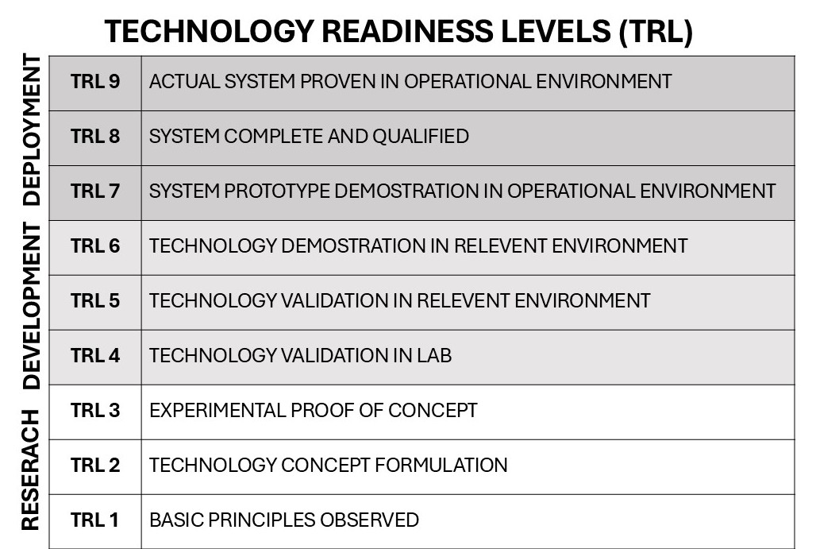

**Instructions**

1. The last date for submission of application is **20th April, 2025 by 05:30 PM.**
2. **A soft copy of the Technology Business Incubator (TBI) proposal in pdf format (by merging filled-in online application from E-PMS portal of DST and also filled-in application format provided along with guidelines, with all enclosures/documents) to be emailed to sureshbabu.muttana@gov.in on or before 20th April, 2025 (11:59 pm).**
3. Attachments/Enclosures as detailed in the form are required for consideration of the proposal by the evaluation committee.
4. All proposals will be evaluated and executed as per the policies and procedures of EVolutionS guidelines of DST.

For any queries, please contact the following officials from DST:

1. **Dr. Anita Gupta**

Adviser & Head

Climate, Energy, and Sustainable Technology (CEST) division

Department of Science and Technology (DST)

Ministry of Science and Technology, Govt. of India

Technology Bhavan, New Mehrauli Road

New Delhi-110016

Ph: 011 - 26523977

E-mail: anigupta@nic.in

2. **Mr. Suresh Babu Muttana**

Scientist 'E'/ Electric Vehicle Program Officer

Climate, Energy, and Sustainable Technology (CEST) division

New S&T Block 1, Room No: 224

Department of Science and Technology (DST)

Ministry of Science and Technology, Govt. of India

Technology Bhavan, New Mehrauli Road

New Delhi-110016

Ph: 011 - 26590593

E-mail: sureshbabu.muttana@gov.in